**Question:**

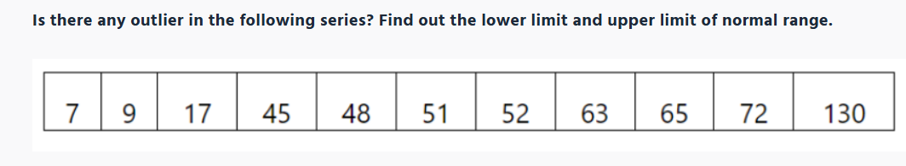

**Answer:**

Outlier is given below:

Q1 = 17

Q3 = 65

IQR = Q3 - Q1

= 65 -17

= 48

Lower = Q1 -(1.5 * IQR) = 17 -(1.5*48) = -55

Upper = Q3 +(1.5 * IQR) = 65+(1.5*48) = 137

The lower value is -55 and upper value is 137, so there is no outlier.